Jack Singley Agenda #3.2
4.17 at 8:15
Irving ISD - https://us02web.zoom.us/j/2367505029

8:15- Check In

Benchmark 1 - School Design - Culture

Benchmark 2 - Target Population--enrollment & course selection status.

Benchmark 3 - Strategic Alliances - IHE updates as move to virtual
For non-exempt students enrolling at higher education institutions in summer 2020, institutions may use either of the following options, depending on other indicators of students’ level of preparation, such as HS GPA, HS course-taking, and non-cognitive factors:
- Enroll the student in the college-level course as part of a corequisite model, in which case, we recommend the support component of the corequisite model be delivered as a non-course based option (NCBO), which includes flexibility for faculty to modify the required support for students who are doing well in the college course, as demonstrated via assessments and other relevant assignments; or
Utilize Rule 4.55(a) (Texas Administrative Code, Chapter 4, subchapter C) “exceptional circumstances” provision for an individual who has no access to TSI testing. Under the “exceptional circumstances” provision, an institution may permit a student to enroll in freshman-level academic coursework without assessment but shall require the student to be assessed not later than the end of first semester

9:15- Benchmark 4 - Curriculum, Instruction and Assessment Workshop - systems for monitoring, tutoring needs, TSI,

Workshop - Texas STEM Framework

Benchmark 5 - Work-Based Learning - a

Nepris is hosting Training 2.0 sessions on the times and days below for several weeks. Please select the day and time of your choice below, then you will have a choice of dates from which you would like to attend:
- Tuesdays from 9:30 - 10:30 am CT
- Thursdays from 12:00 - 1:00 pm CT
- Thursdays from 3:00 - 4:00 pm CT
Videos in Health Sciences, Robotics, Tech Support -- several are companies/employers in the South--ATT, New Orleans hospitals, City of Irving. Also micro videos 2-5 minutes long.

Benchmark 6 - Student Support - Summer Bridge, Mobilize

Next Steps | Provided Resource
Register for Summit | https://www.edtx.org/get-involved/events/ccrsm-2020-leadership-summit
Dates | Dates for Future Meetings - May 5 will complete with 4 visits for designated
Trauma with Students Webinars | https://www.edelements.com/webinars
Academic Vocab | https://lead4ward.com/resources/
TEA Covid 19 | https://tea.texas.gov/texas-schools/health-safety-discipline/coronavirus-covid-19-support-and-guidance

Name | Title | Role | Signature
Lisa Casto | Coach | Coach | 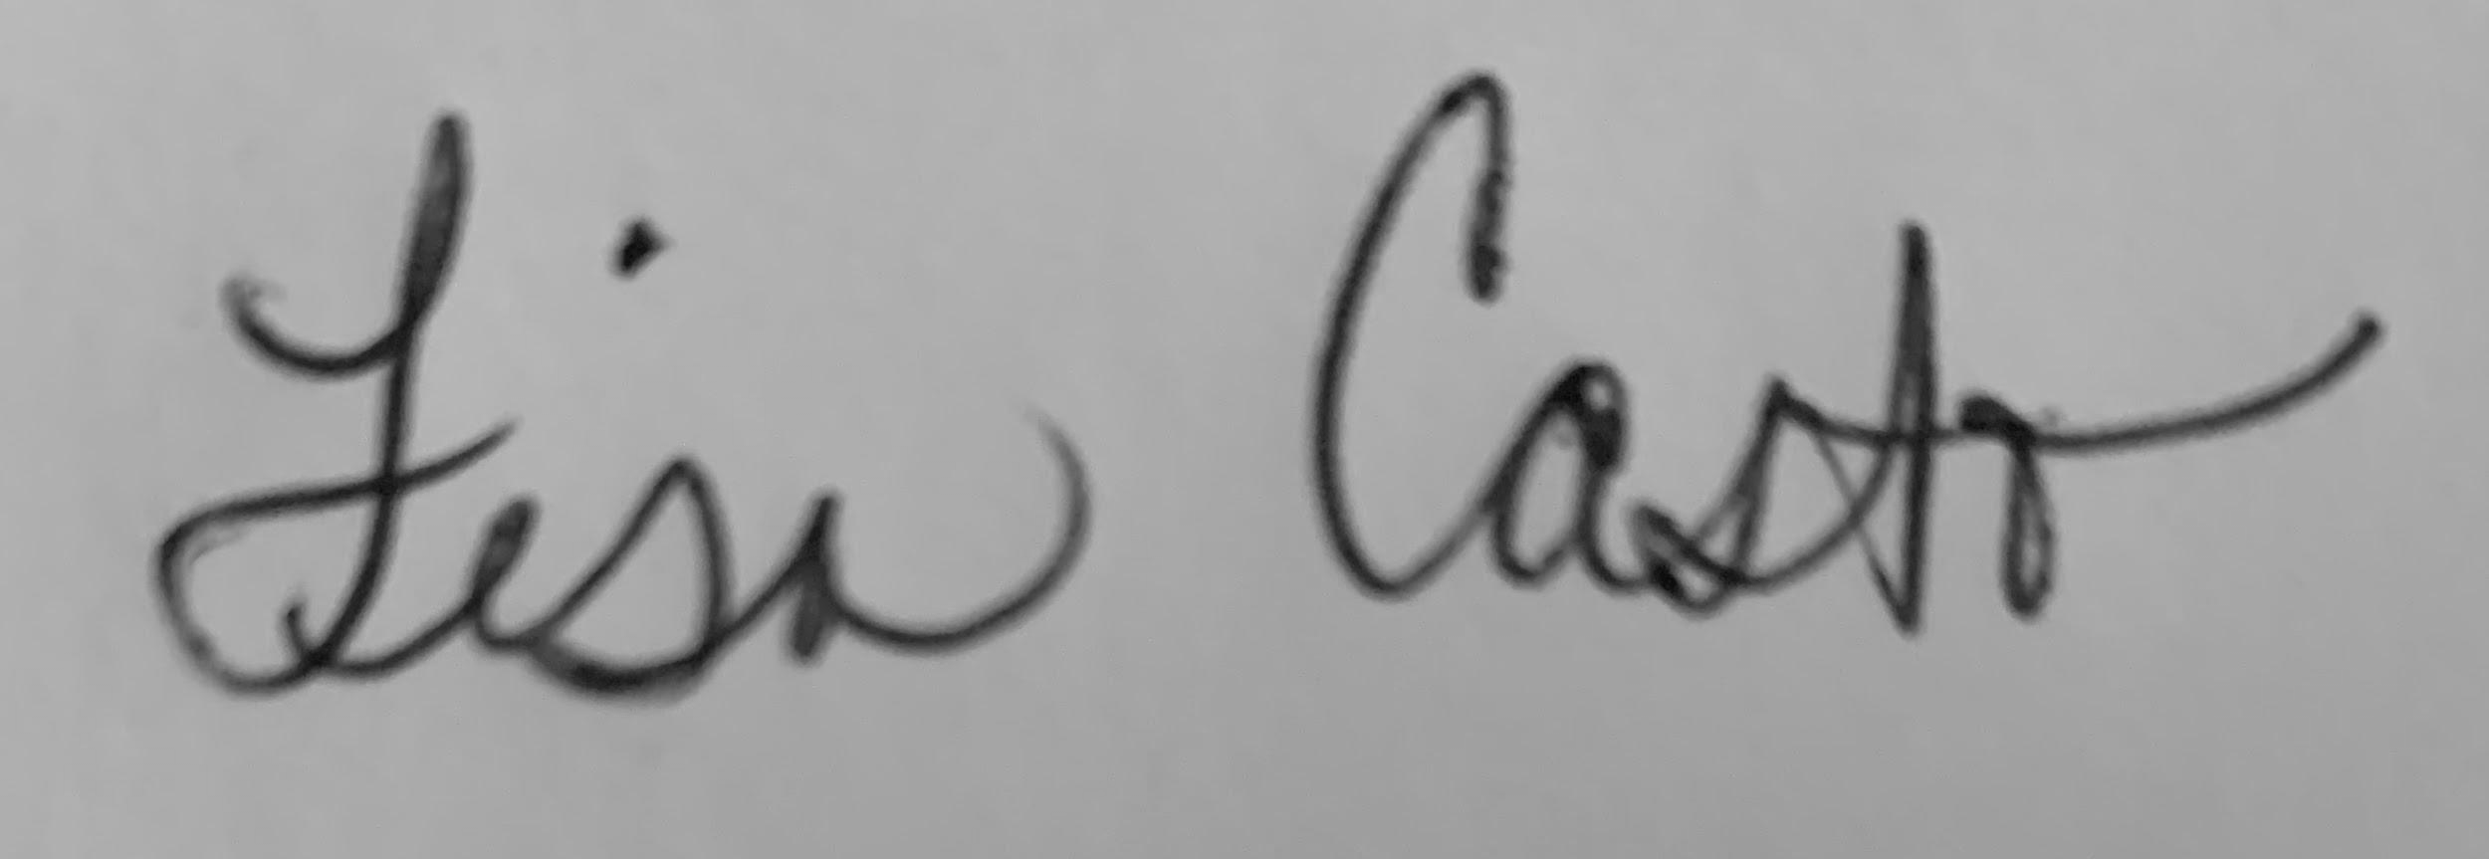
Jenny Anderson | Assistant Principal | Administrator | 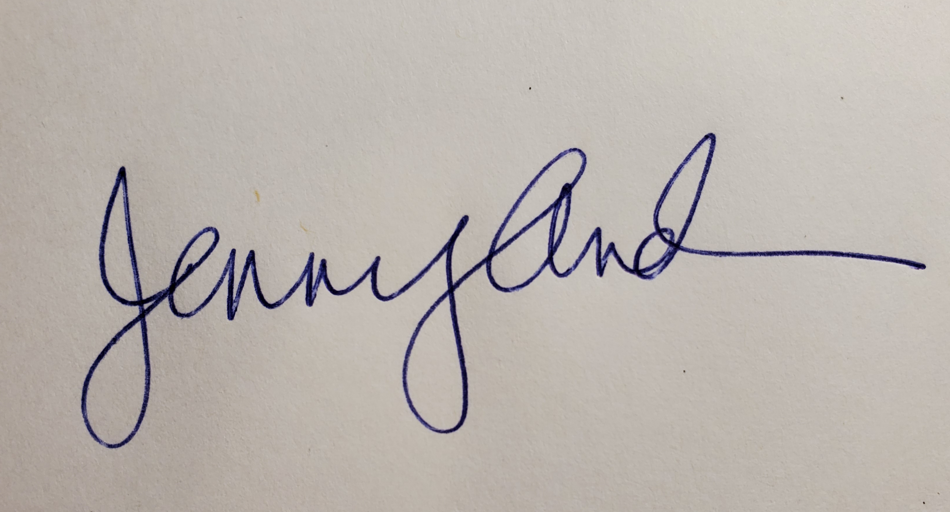
Katie Crone | Academic Specialist | Coordinator
Rachel Lomax | Lead Counselor | Lead Counselor | 